Define Cloud Infrastructure and Reusable Components Using AWS CloudFormation

Lab scenario
In this lab, you will be a DevOps engineer at a financial services company called "FinTechBuddy". FinTechBuddy offers personalized financial management solutions to users. It helps individuals manage their budget, track expenses, and make informed financial decisions through data analytics and machine learning algorithms. The company wants to implement the best practices on cloud infrastructure and reusable components throughout the infrastructure lifecycle. You will use AWS CloudFormation StackSets to define cloud infrastructure for the company across multiple AWS Regions. You will leverage the principle of reusable components by defining a Networking CloudFormation stack that is later cross-referenced in the Application CloudFormation stack.

Create Administration & Execution Roles for AWS CloudFormation Service
Create the administration and execution roles for AWS CloudFormation service. This task ensures that the necessary permissions have been created for creating AWS CloudFormation stacks across different AWS Regions using StackSets.

Create the administration role for the AWS CloudFormation service
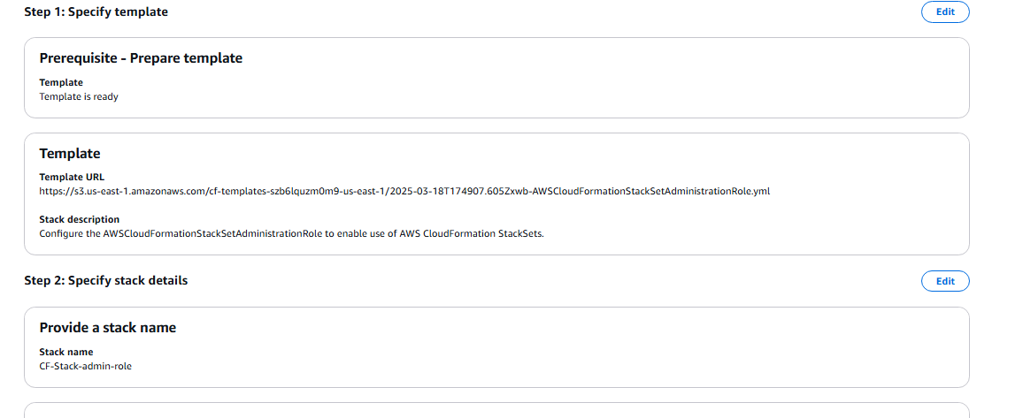

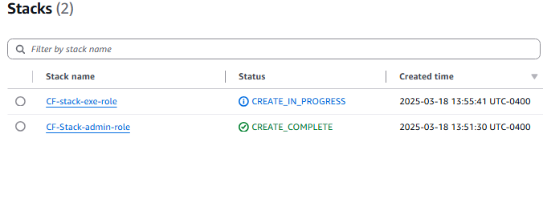
You can verify that the IAM roles have been created by navigating to the IAM service and clicking on Roles in the left sidebar. You should see that the two relevant roles are listed.

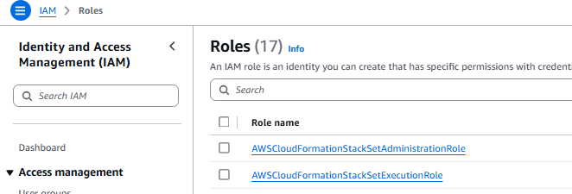

You should see that the FinTechBuddyAppNetworkingStackSet StackSet has been created successfully.
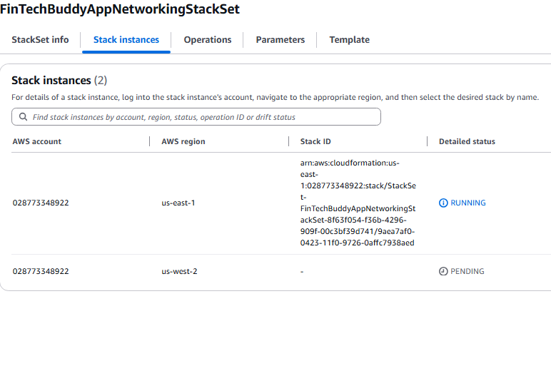

Create Application Infrastructure StackSet
Create the template for the application stack using AWS CloudFormation. Use the AWS CloudFormation StackSet to simultaneously provision the application infrastructure in the N.Virginia and Oregon AWS Regions. Leverage the principle of reusable components by using the elements from the Networking CloudFormation StackSet. The AWS CloudFormation StackSet will provision public EC2 instances in each of the two AWS Regions. Then, the user should be able top SSH into the instances via EC2 Instance Connect service.
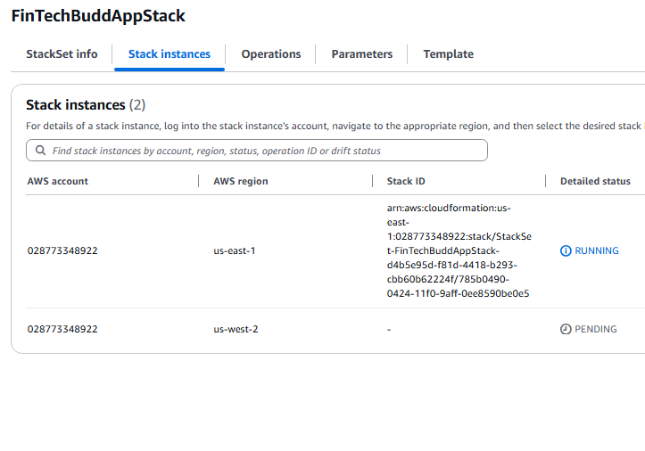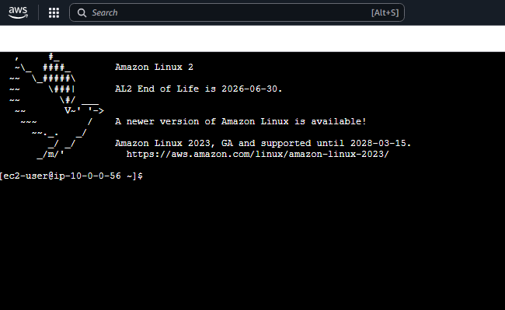

Upgrade the Application Infrastructure StackSet
Leveraging the principle of managing Infrastructure as Code (IaC), update the AWS CloudFormation template for the application stack to upgrade the EC2 instance type from t2.micro to t2.small. Use the AWS CloudFormation StackSet to simultaneously re-provision the infrastructure in the N.Virginia and Oregon AWS Regions. The revised application StackSet will result in public EC2 instances of t2.small instance type in each of the two AWS Regions. Then, the user should be able to SSH into the instances via EC2 Instance Connect service.
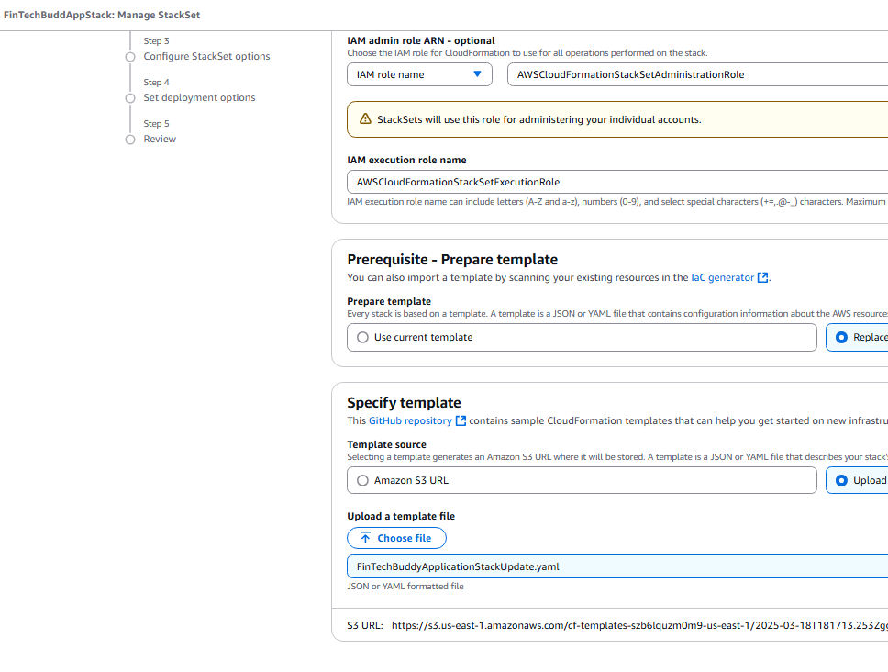

You should see that the instance type is t2.small. Select the checkbox for the running EC2 instance and click on the Connect button.
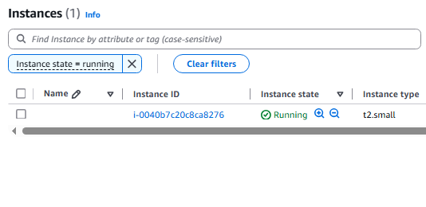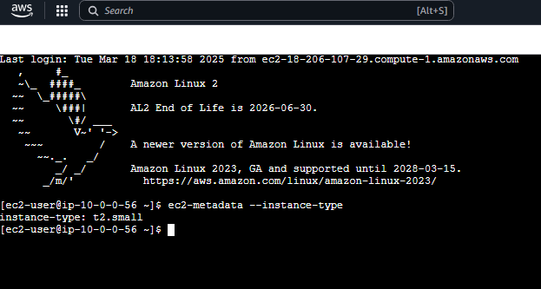

Oregon
